**Memo from Chief of Staff and President/CEO**

**to ALL Staff**



**Date:** xxxx, 2020

Please be advised that **EFFECTIVE IMMEDIATELY** we have limited the number of entrances/exits available to ANYONE coming to WRH, including our employees, volunteers and professional staff.

WRH team members are advised to use the following entrances ONLY:

**Met Campus**

Employees and professional staff may enter through the east side doors of the main entrance; the main Emergency Department entrance; and the main Cancer Centre entrance. Note the areas in red where access is locked.

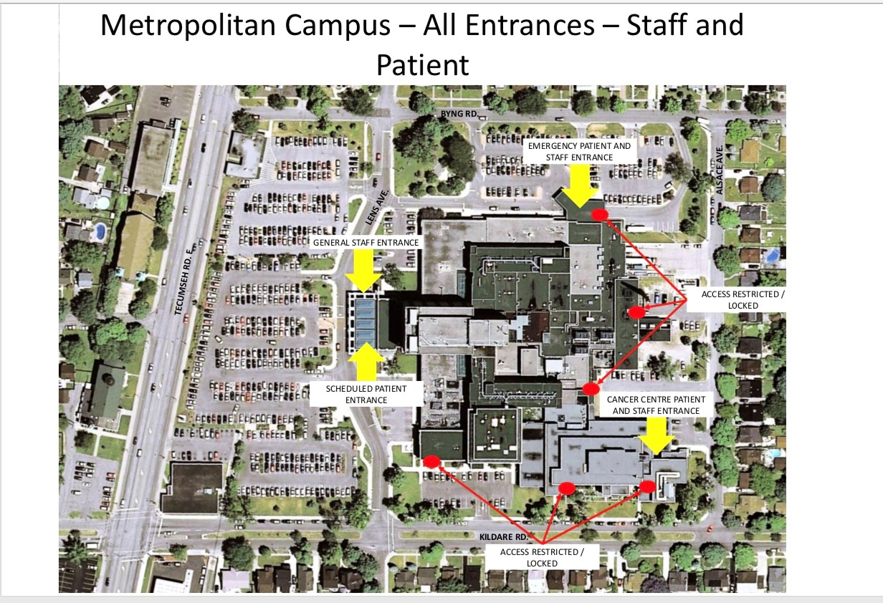

**Ouellette Campus**

Employees and professional staff may enter through the third level parking garage entrance; the main Goyeau lobby entrance and the main Emergency Department entrance. Those attending the Jeanne Mance building can enter through the east side doors noted on the map below. Those attending the Bell Building (dialysis) can enter only from the east side entrance off Goyeau St. Note the areas in red where access is locked.

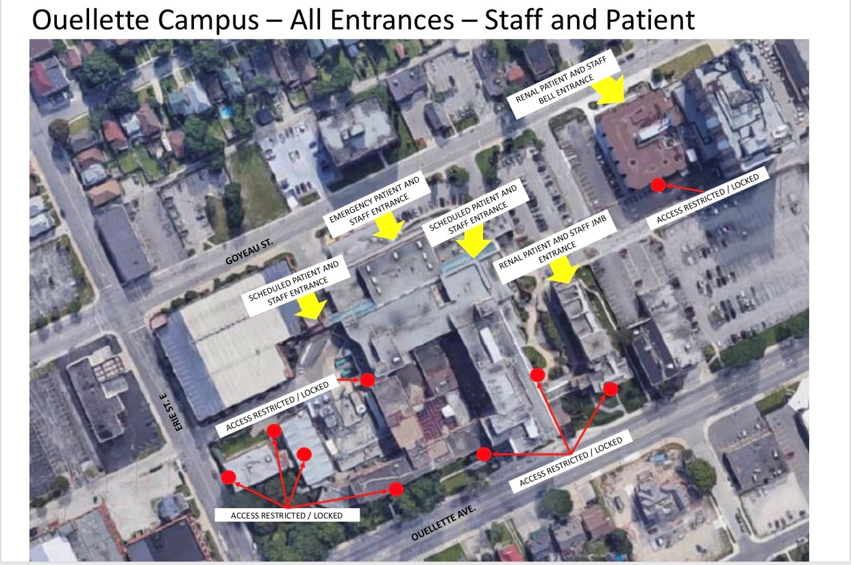

Note that like all patients and visitors, you will be SCREENED for potential symptoms of COVID-19 before leaving the entrance area. Please allow extra time coming to work in order to account for the time it takes to get through screening.

We appreciate your patience while we work to keep all of our WRH team and our guests safe.